* ***-- 1. Write a query to find the address (location_id, street_address, city,state_province, country_name) of all the departments --***

SELECT location_id, street_address, city, state_province, country_name

FROM locations

NATURAL JOIN countries ;

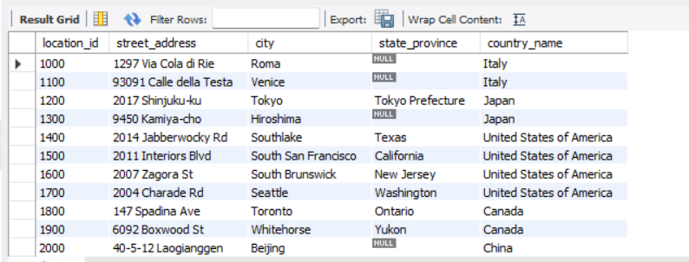

* ***--2. Write a query to find the name (first_name, last name), department ID and name of all the employees --***

SELECT first_name, last_name, concat(first_name," ",last_name) as Name, department_id, department_name

FROM employees

JOIN departments USING (department_id);

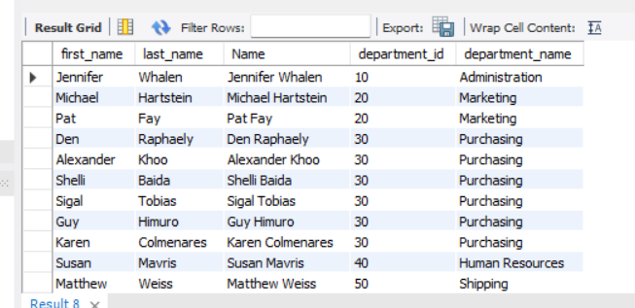

* ***-- 3. Write a query to find the name (first_name, last_name), job, department ID and name of the employees who works in London --***

SELECT e.first_name, e.last_name, e.job_id, e.department_id, d.department_name

FROM employees as e

JOIN departments as d

ON (e.department_id = d.department_id)

JOIN locations as l ON (d.location_id = l.location_id)

WHERE LOWER(l.city) = 'London';

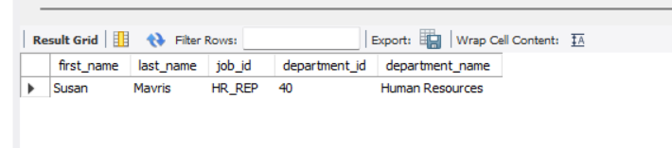

* ***-- 4. Write a query to find the employee id, name (last_name) along with their manager_id and name (last_name) --***

SELECT e.employee_id 'Emp_Id', e.last_name 'Employee',

m.employee_id 'Mgr_Id', m.last_name 'Manager'

FROM employees as e

join employees as m

ON (e.manager_id = m.employee_id);

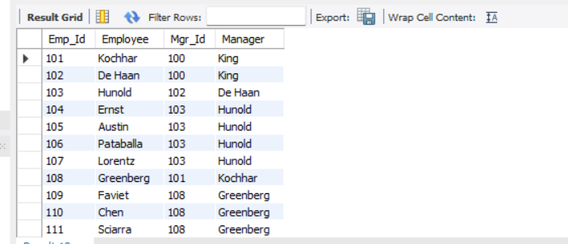

* ***-- 5. Write a query to find the name (first_name, last_name) and hire date of the employees who was hired after 'Jones' --***

SELECT e.first_name, e.last_name, e.hire_date

FROM employees as e

JOIN employees as d

ON (d.last_name = 'Jones')

WHERE d.hire_date < e.hire_date;

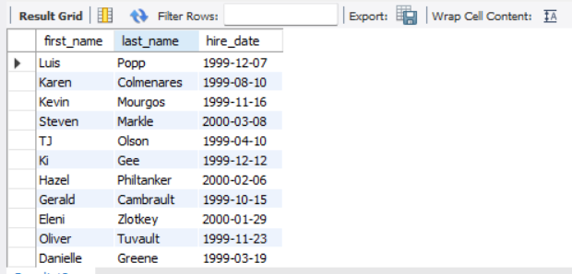

* ***-- 6. Write a query to get the department name and number of employees in the department --***

SELECT department_name AS 'Department Name',

COUNT(*) AS 'No of Employees'

FROM departments

INNER JOIN employees

ON employees.department_id = departments.department_id

GROUP BY departments.department_id, department_name

ORDER BY department_name;

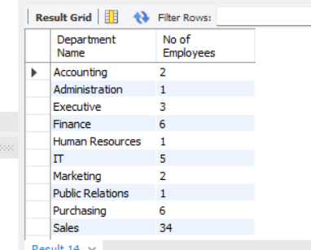

* ***-- 7. Write a query to display department name, name (first_name, last_name), hire date, salary of the manager for all managers whose experience is more than 15 years –***

SELECT concat(first_name," ",last_name) as Name ,department_name,hire_date, salary,

(DATEDIFF(now(), hire_date))/365 Experience

FROM departments as d

JOIN employees as e

ON (d.manager_id = e.employee_id)

WHERE (DATEDIFF(now(), hire_date))/365>15;

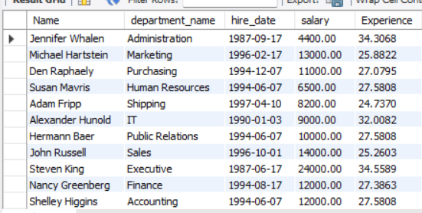

* ***-- 8. Write a query to find the name (first_name, last_name) and the salary of the employees who have a higher salary than the employee whose last_name='Bull' –***

SELECT concat(first_name," ",last_name) as Name,salary

FROM employees

WHERE SALARY > (SELECT salary FROM employees WHERE last_name = 'Bull');

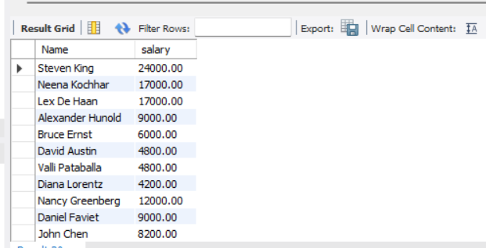

* ***--9. Write a query to find the name (first_name, last_name) of all employees who works in the IT department --***

SELECT concat(first_name, " ",last_name) Name

FROM employees

WHERE department_id

IN (SELECT department_id FROM departments WHERE department_name='IT');

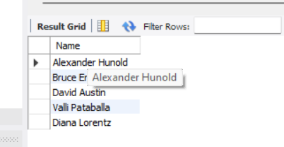

* ***--10. Write a query to find the name (first_name, last_name) of the employees who have a manager and worked in a USA based department --***

SELECT first_name, last_name FROM employees

WHERE manager_id in (select employee_id

FROM employees WHERE department_id

IN (SELECT department_id FROM departments WHERE location_id

IN (select location_id from locations where country_id='US')));

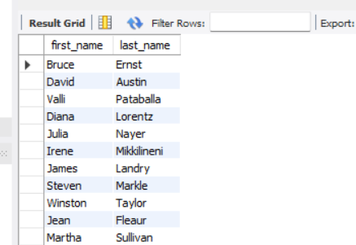

* ***-- 11. Write a query to find the name (first_name, last_name), and salary of the employees whose salary is greater than the average salary --***

SELECT first_name, last_name, salary FROM employees

WHERE salary > (SELECT AVG(salary) FROM employees);

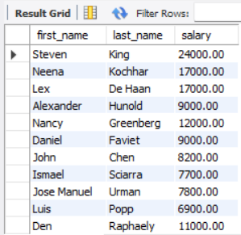

* ***-- 12. Write a query to find the name (first_name, last_name), and salary of the employees whose salary is equal to the minimum salary for their job grade --***

SELECT first_name, last_name, salary

FROM employees

WHERE employees.salary = (SELECT min_salary

FROM jobs

WHERE employees.job_id = jobs.job_id);

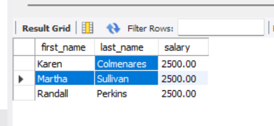

* ***-- 13. Write a query to find the name (first_name, last_name), and salary of the employees who earns more than the average salary and works in any of the IT departments --***

SELECT first_name, last_name, salary

FROM employees

WHERE department_id IN

(SELECT department_id FROM departments WHERE department_name LIKE 'IT%')

AND salary > (SELECT avg(salary) FROM employees);

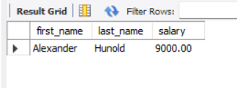

* ***-- 14. Write a query to find the name (first_name, last_name), and salary of the employees who earn the same salary as the minimum salary for all departments***.

SELECT first_name,last_name,salary FROM employees

WHERE salary = (SELECT MIN(salary) FROM employees);

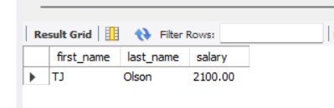

* ***-- 15. Write a query to find the name (first_name, last_name) and salary of the employees who earn a salary that is higher than the salary of all the Shipping Clerk (JOB_ID = 'SH_CLERK'). Sort the results of the salary of the lowest to highest --***

SELECT first_name,last_name, salary

FROM employees

WHERE salary >

ALL (SELECT salary FROM employees WHERE job_id = 'SH_CLERK') ORDER BY salary;

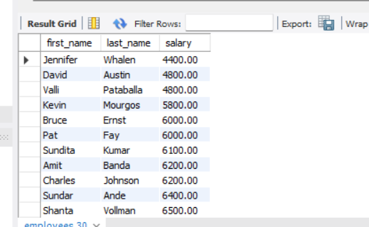

Q

**By**

Alwin Mathew

Email: alwinmathew143@gmail.com